EDITORIAL NOTE (remove before submission): This chapter was drafted in full by Claude (Anthropic), per the student's explicit authorization and Hochschule Nordhausen's own AI-usage policy for thesis work, which permits full AI generation of chapter text and data analysis provided the AI's role is disclosed and the student substantially rewrites the content before submission (the policy explicitly prohibits unmodified AI text for the chapter that 'summarises state of research'; this draft is intended strictly as a starting point for the student's own rewrite, not as final submitted text). Prompt citation: Claude Sonnet 5 (Anthropic), output generated 18 September 2026, session https://claude.ai/code/session_01VmiP7rpUwBmA2YjSGWGxHo, prompt: research and draft Chapter 2 ("Basics") of a Master's thesis comparing AMIRIS against Energy Brainpool for the German day-ahead electricity market 2027-2029, covering agent-based market modelling, day-ahead market mechanics, the AMIRIS model, European market coupling, German market context, resource adequacy assessment, and model validation methodology, using only independently verified real sources. All citations below were independently checked against live sources during drafting (see verification notes at the end of this document); two corrections were made to an earlier, unverified draft's citations (see Verification Notes). Wikipedia was not used as a source, per Hochschule Nordhausen's Scientific Practice guidance.

Chapter 2: Basics

2.1 Agent-based modelling of electricity markets
Electricity markets can be modelled in several fundamentally different ways. A reduced-form or statistical model treats the market price as a function to be fitted directly to historical drivers such as load, weather, and fuel costs, without representing the market's internal clearing mechanism at all. An optimisation-based model, common in system-planning contexts, finds the generation dispatch that minimises total system cost subject to technical constraints, implicitly assuming that the market outcome equals the cost-minimal one. An agent-based model takes a third approach: rather than solving for an aggregate optimum or fitting a statistical relationship, it represents each category of market participant as a separate, explicitly programmed decision-making entity, each following its own bidding rule, and derives the market price as the emergent outcome of those individual agents' bids being cleared against one another.
The first of these approaches, reduced-form or statistical forecasting, has itself become a substantial research field in its own right. Lago et al. (2021), in a widely used benchmarking review, compare a broad range of statistical and machine-learning day-ahead price forecasting methods against a shared open dataset and find that model choice interacts strongly with the specific market and forecast horizon being tested, with no single method dominating across all cases. More recent work has explored combining a fundamental, structurally specified model with a statistical one rather than treating the two approaches as mutually exclusive: Watermeyer et al. (2023) report that a hybrid model blending a fundamental representation of the German market with a stochastic residual component outperforms either component used alone on day-ahead forecast accuracy. AMIRIS and a commercial forecaster such as Energy Brainpool occupy different points along this same spectrum: AMIRIS is a fully fundamental, agent-based model of the kind described below, while a commercial day-ahead forecast product typically combines statistical and fundamental elements to a degree that is not usually disclosed publicly, a distinction returned to directly in Section 2.7.
Weidlich and Veit (2008), in an early and still widely cited survey of agent-based wholesale electricity market models, set out the case for this approach on the grounds that real electricity markets are not populated by a single optimising planner but by numerous participants with heterogeneous costs, risk preferences, and strategic behaviour, and that a model built from the bottom up around individual agent decisions can, in principle, capture market dynamics such as strategic bidding and imperfect competition that a top-down cost-minimisation model assumes away by construction. Their survey also catalogues the trade-off this approach carries: an agent-based model's realism and transparency come at the cost of its behaviour depending heavily on how each agent type's bidding rule is specified, which means that two agent-based models built on the same underlying market data can produce materially different results if their agents are configured to behave differently. This is precisely the distinction that motivates the identical-input comparison design adopted in this thesis, since the same dependency on agent-level configuration choices is what makes it necessary to control the input data before any observed difference between two models can be attributed to their internal logic with confidence.
Most published agent-based electricity market models, including the foundational applications Weidlich and Veit (2008) survey, represent a single price zone in isolation. Extending the approach to interconnected zones introduces additional agent-level complexity: an interconnector's available capacity has to be represented explicitly, and the market-clearing procedure has to decide, for each simulated hour, how much energy actually flows across each border alongside setting every connected zone's own price. Two established platforms illustrate how this can be done. MASCEM (Multi-Agent System for Competitive Electricity Markets), developed at the Polytechnic Institute of Porto, represents strategic market participants bidding into simulated day-ahead and balancing markets, and has been extended across a series of publications to support scenario analysis involving multiple interacting market areas (Vale et al., 2011). POMATO (Power Market Tool), an open-source Python/Julia model developed at TU Berlin, takes a complementary approach: rather than modelling strategic agent behaviour in fine detail, it focuses on the interaction between zonal market clearing and the physical transmission network, explicitly implementing both net-transfer-capacity and flow-based capacity representations so that the effect of the underlying capacity-allocation method on simulated zonal prices can itself be examined (Weinhold and Mieth, 2020). Neither tool is used directly in this thesis, but both illustrate a design choice this thesis's own eleven-zone AMIRIS build has to make explicitly: how cross-border capacity is represented is not a detail subordinate to the market-clearing logic, it is itself a modelling decision with first-order consequences for the simulated price in every connected zone, a point developed further in Section 2.4.

2.2 Day-ahead market mechanics: merit order and uniform pricing
The day-ahead market is the auction in which most European wholesale electricity is traded, one day before physical delivery, for each hour of the following day separately. Generators submit offers stating a quantity of energy and a minimum price at which they are willing to sell it; buyers submit bids stating a quantity and a maximum price they are willing to pay. The exchange operator ranks all accepted generator offers from cheapest to most expensive, a sequence generally referred to as the merit order, and accepts offers in that order until the accumulated quantity matches demand for that hour (EPEX SPOT, no date a). The price of the last, most expensive offer needed to meet demand becomes the single clearing price for that hour, and, critically, every accepted offer is paid this same clearing price regardless of how cheaply it was actually willing to sell, a convention known as uniform pricing or pay-as-cleared pricing. A generator that bid well below the clearing price is not paid its own bid; it receives the higher clearing price, which is what gives low-cost, price-inelastic generators such as nuclear and renewable plants an incentive to bid very low, since doing so all but guarantees dispatch while the settlement price is nonetheless set by whichever plant happens to be marginal.
The merit order is not fixed; it shifts hour to hour as fuel and carbon prices move and as renewable output varies, and a generation technology's position within it is what determines whether it dispatches in a given hour at all. This is also the mechanism through which fuel and carbon price movements translate into price volatility, since a rise in the marginal fuel's cost shifts the entire merit order upward for exactly those hours in which that fuel sets the price (FfE, no date). An agent-based model such as AMIRIS reproduces this mechanism directly rather than approximating it: each agent submits a bid computed from its own cost structure, and the simulated exchange performs the same rank-and-accept clearing procedure a real exchange would.
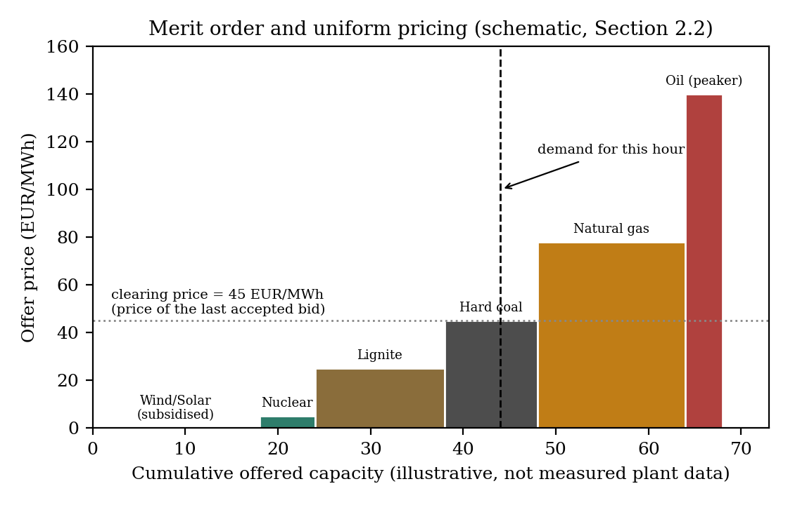
Uniform pricing resolves the normal case, where enough generation offers are available to meet demand at some finite price. European day-ahead markets also define what happens in the much rarer case where they cannot: a harmonised maximum clearing price, administratively set by the Agency for the Cooperation of Energy Regulators (ACER) rather than derived from any generator's own bid, caps the price in any hour where accepted supply still falls short of demand at every price up to that ceiling (ACER, 2023). This ceiling is intended as a practical proxy for the value of lost load (VoLL), the economic cost a consumer would incur from an unserved unit of demand, a quantity that is itself difficult to estimate directly and the subject of a substantial dedicated literature. Praktiknjo (2016) estimates VoLL for the German market sector by sector, finding it varies by roughly two orders of magnitude between the least and most outage-sensitive industries, while Gorman (2022) critically reviews the wider methodological difficulty of deriving a single such figure from the heterogeneous, context-dependent costs outages actually impose. AMIRIS's own example scenarios represent this mechanism with a single configurable Value of Lost Load parameter applied uniformly whenever demand cannot be met, a simplification directly relevant to interpreting the shortage-hour results described in later chapters.
Figure 2.1: Merit order and uniform pricing (schematic illustration of the mechanism described above, not measured plant-level bid data).

2.3 The AMIRIS model

2.3.1 Model architecture and agent types
AMIRIS (Agent-based Market model for the Investigation of Renewable and Integrated energy Systems) is an open-source simulation model developed at the German Aerospace Center (Deutsches Zentrum fur Luft- und Raumfahrt, DLR) for representing the German day-ahead electricity market at hourly resolution over a full simulated year (Schimeczek et al., 2023a; DLR, no date). AMIRIS is itself built on FAME (Framework for Agent-based Models of Energy systems), DLR's own open-source platform for constructing and executing this kind of distributed multi-agent simulation (Schimeczek et al., 2023b); the market-specific agent types described below are an AMIRIS-level implementation on top of FAME's more general agent-communication and scheduling infrastructure, not a single monolithic, purpose-built program. Its architecture separates market participants into distinct agent types by function rather than modelling the market as a single aggregate supply-and-demand curve. Conventional generation (nuclear, lignite, hard coal, natural gas, and oil) is represented through a PredefinedPlantBuilder agent per fuel type, which takes a fleet-level installed capacity, an efficiency range, and a representative individual plant size, and constructs a portfolio of individual simulated plant blocks from those three numbers, each block assigned a slightly different efficiency drawn across the given range so that the fleet does not bid as a single undifferentiated unit. A ConventionalTrader agent then bids that fuel type's plants into the market at a marginal cost calculated from fuel price, plant efficiency, carbon price, and a specific emissions factor, plus a markup drawn from a configured range that differs by fuel type and can be negative for technologies such as nuclear, reflecting the real-world fact that shutting down and restarting an inflexible plant is often more expensive than continuing to run it at a loss for a few hours.
Renewable generation is represented differently, through VariableRenewableOperator and related agent types (RenewableTrader, NoSupportTrader, SystemOperatorTrader depending on how the plant is marketed), each linked to an hourly capacity-factor time series specific to its technology that determines how much of its nameplate capacity is actually available to produce in a given hour, since a wind or solar plant's true output is weather-dependent rather than a matter of choice. A separate SupportPolicy agent administers whichever subsidy scheme applies to a given renewable cluster, most commonly either a feed-in tariff, under which the plant receives a fixed guaranteed price per MWh regardless of the market price it happened to clear at, or a variable market premium, under which the plant sells at the market price and separately receives a top-up calculated against a reference cost figure. Storage is represented through GenericFlexibilityTrader agents, each with its own charging and discharging power limits, round-trip efficiency, and energy capacity, dispatched according to a configurable strategy that can target either minimum system cost or the storage operator's own profit, using a forecast over a rolling scheduling horizon rather than perfect foresight of the full simulated year.
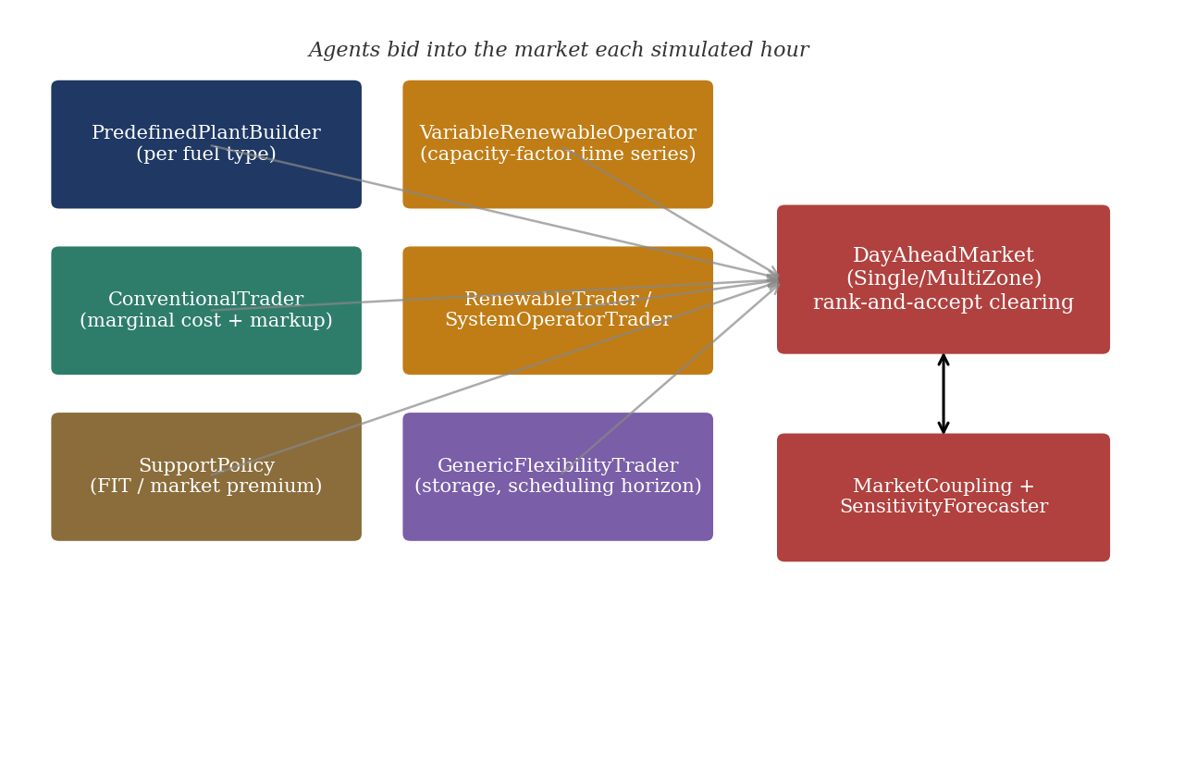
How profitable such flexibility options actually are once deployed at scale, rather than merely how they are implemented in software, is itself an active research question within this same agent-based modelling tradition. Nitsch (2025), in a doctoral study using this same approach, finds that the economic viability of flexibility options such as storage depends materially on how much capacity is deployed collectively across the system, since each additional unit of flexibility erodes part of the price spread earlier units relied on to be profitable, a cannibalisation effect only visible once flexibility is modelled at a system level rather than for a single unit in isolation; a related study combines this agent-based approach directly with price forecasting to assess flexibility option potential (Nitsch and Schimeczek, 2025). This system-level interaction is one further reason storage dispatch in this thesis's own scenarios is left at AMIRIS's example configuration rather than re-optimised, since doing so convincingly would require reproducing this kind of dedicated system-level study rather than adjusting a single agent's parameters in isolation.
Figure 2.2: AMIRIS agent architecture: how the agent types described above interact with the day-ahead market and, for multi-zone scenarios, the market-coupling and forecasting components (own illustration, based on the model description in Schimeczek et al., 2023a and this project's own scenario configuration files).

2.3.2 Bid formation and market clearing in AMIRIS
The bid a conventional generation agent submits in AMIRIS follows directly from its underlying cost structure. Marginal cost per MWh of electricity produced is calculated as the fuel price divided by the plant's efficiency, plus the carbon price multiplied by the plant's specific emissions factor, plus a fixed variable operating cost:
marginal cost = (fuel price / efficiency) + (carbon price x emissions factor) + variable operating cost
A trader agent then adds a markup drawn from a configured range specific to that fuel type to arrive at the actual bid submitted to the exchange. Renewable agents typically bid at or near their variable operating cost, commonly configured as zero, since their subsidy arrangement decouples their real earnings from the market price they help to set. Once all agents have submitted bids for a given hour, AMIRIS's DayAheadMarketSingleZone agent performs the same rank-and-accept clearing procedure described in Section 2.2: bids are accepted from cheapest to most expensive until accumulated supply meets demand, the price of the last accepted bid becomes that hour's clearing price, and every accepted agent, whatever its own bid, is paid that single price. This is also the specific mechanism behind a structural finding this thesis's earlier backtesting work identified: because renewable and no-support trader agents in AMIRIS's example scenarios are configured to bid at exactly zero rather than being permitted a negative markup range, the simulated price cannot fall below zero even in hours where enough zero-cost supply is available to force a real market into negative territory, a behaviour the conventional generator agents are structurally capable of but the renewable agents, as configured, are not.
For multi-zone scenarios, AMIRIS additionally defines a DayAheadMarketMultiZone agent and cross-zonal Transmission entries specifying, per zone pair, an available transfer capacity time series; the model also defines an ImportTrader agent capable of injecting an exogenous import supply curve at a specified cost for representing trade with a zone that is not itself simulated. Whether a given scenario file uses a single isolated zone, a star topology connecting every zone only to Germany, or a full mesh of real bilateral interconnections is a configuration choice made by the scenario author rather than a constraint of the software itself, a distinction this thesis's own market-coupling scenario work, described in later chapters, depends on directly.

2.4 European day-ahead market coupling

2.4.1 The EUPHEMIA algorithm and Single Day-Ahead Coupling
Section 2.2 described day-ahead price formation within a single market zone. Where a scenario connects several separate zones, as this thesis's eleven-zone build does, that single-zone description is incomplete: the price in any one zone can no longer be determined without simultaneously considering the prices and available cross-border capacity in every zone it is connected to. Since November 2014, the day-ahead markets of most of Continental Europe have been jointly cleared through Single Day-Ahead Coupling (SDAC), operated jointly by the region's power exchanges (Nominated Electricity Market Operators, or NEMOs) and transmission system operators under a shared computational algorithm called EUPHEMIA, the Pan-European Hybrid Electricity Market Integration Algorithm (ENTSO-E, no date b; NEMO Committee, 2025). EUPHEMIA performs implicit auctioning: rather than clearing each zone's market independently and separately trading the resulting price differences across borders afterwards (explicit auctioning), it solves a single simultaneous optimisation across all coupled zones that maximises total welfare, the sum of accepted bid and offer surplus, subject to each zone's own supply-demand balance and the available transfer capacity on every interconnector between them, determining each zone's clearing price, the resulting cross-border flows, and the accepted orders in every zone in a single pass (NEMO Committee, 2025).
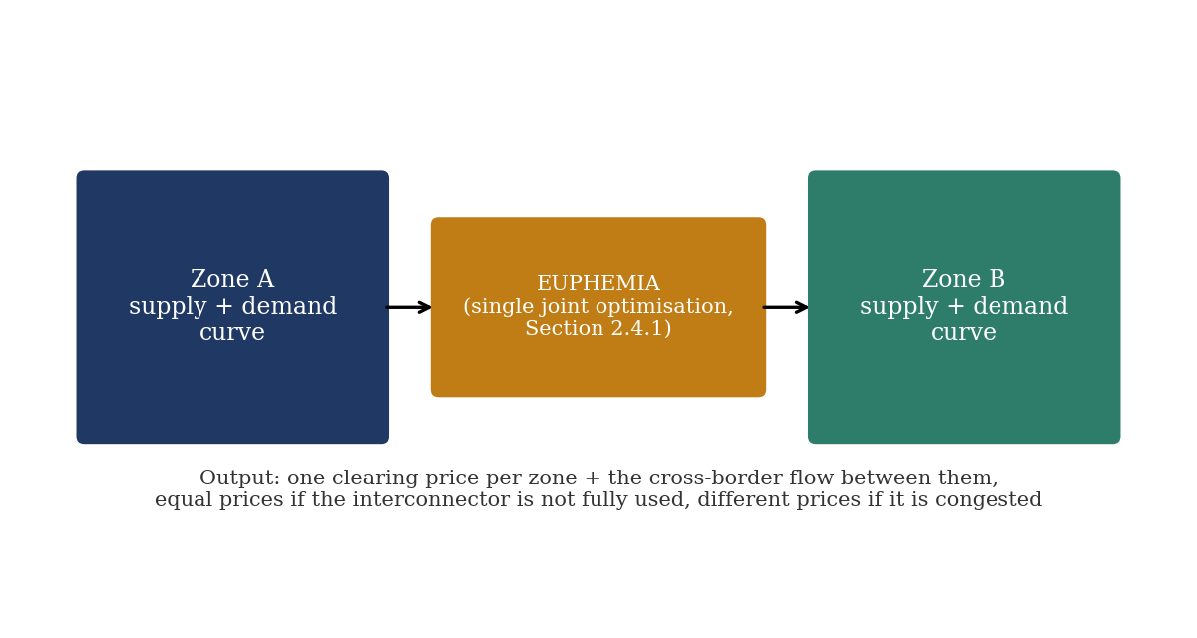
Figure 2.3: Implicit auctioning under market coupling: a single joint optimisation sets both zones' prices and the cross-border flow between them simultaneously (own illustration of the mechanism described above).

A structural consequence of this design, directly relevant to interpreting any multi-zone simulation result, is that two zones connected by transmission capacity that is not fully used in a given hour will clear at the same price, while a zone whose import capacity is fully used, or congested, can clear at a materially different, usually higher, price than its neighbours. Price convergence across zones is therefore not a fixed outcome of being interconnected at all, but an hour-by-hour function of each zone's own supply-demand balance relative to the capacity actually available to it in that hour.

2.4.2 Capacity allocation: NTC-based and flow-based methods
How much cross-border capacity EUPHEMIA is even permitted to allocate between two zones in a given hour is determined upstream, by a separate capacity-calculation process, and European transmission system operators use one of two broad methods to do this. Under the coordinated net transfer capacity (NTC) method, each transmission system operator computes, independently, the maximum power flow it judges its own network can securely accommodate on a given border in each direction, and the lower of the two neighbouring operators' figures is passed to the market coupling algorithm as that border's tradable capacity for the hour. Because each operator's NTC figure is computed without directly modelling how a trade on one border affects loading on other network elements nearby, a real physical effect since power flows follow the path of least electrical resistance rather than a contractual path, NTC values are frequently set conservatively to guard against this unmodelled risk. The flow-based method addresses this directly: rather than a single capacity figure per border, it computes, for every hour, how a marginal trade on each border would load every relevant network element in the wider region, a set of relationships known as power transfer distribution factors, and passes the resulting set of linear constraints to the market coupling algorithm, which can then allocate capacity across multiple borders simultaneously in whatever combination respects every network element's true physical limit. Flow-based capacity calculation has applied to the day-ahead Core capacity calculation region, which includes Germany, France, Austria, and the Czech Republic among others, since 2015, while several of this thesis's other modelled zones continue to use NTC-based allocation (Nordic RCC, no date).
This distinction matters for how this thesis's own bilateral transmission figures should be interpreted. Values sourced from ENTSO-E's ERAA/PEMMDB dataset for NTC-based borders (described further in Section 2.6) represent a genuine, directly usable pre-computed capacity limit of essentially the same kind EUPHEMIA itself would use. For a flow-based border, a single NTC-equivalent figure is, at best, an approximation of a genuinely multi-dimensional physical constraint; AMIRIS's own single-value-per-border transmission representation does not attempt to reproduce flow-based allocation in full, and this simplification is an explicit, acknowledged limitation of the market-coupling scenario work described in later chapters rather than an oversight.

2.5 The German electricity market context

2.5.1 Renewable support schemes: feed-in tariffs and market premiums
Germany's principal legal instrument for subsidising renewable electricity generation is the Erneuerbare-Energien-Gesetz (Renewable Energy Sources Act, EEG), which has historically supported plant operators through two main mechanisms that coexist for different plants depending on size, technology, and commissioning date. Under a feed-in tariff, the operator receives a fixed price per MWh for every unit of electricity fed into the grid, entirely independent of the market price obtained for it; this arrangement removes any commercial incentive for the operator to withhold production even when the market price is very low or negative, since income is guaranteed regardless. Under the market premium scheme that has progressively replaced fixed feed-in tariffs for larger installations, the operator instead sells directly into the market at the prevailing price and separately receives a variable top-up payment intended to bring total revenue up toward a reference cost level, a design intended to give operators at least some incentive to respond to market price signals rather than none at all. Both mechanisms appear directly in AMIRIS's own scenario configuration through the SupportPolicy agent described in Section 2.3.1, which administers whichever scheme applies to each renewable technology and subsidy vintage.

2.5.2 Negative electricity prices
Negative day-ahead prices are an observed, recurring feature of the German market rather than an anomaly, arising in hours where available zero-marginal-cost or subsidised supply exceeds demand and some portion of that supply is nonetheless willing to pay to keep producing rather than shut down. Subsidised renewable operators under a feed-in tariff have no financial reason to curtail even at a negative market price, since their income is fixed regardless; certain conventional plants, particularly nuclear and some lignite units, can also find it cheaper to bid negative and keep running than to shut down and restart later, given the technical and financial costs that cycling a large thermal plant incurs. The clearest documented instances in the years covered by this thesis's own earlier backtest occurred on public holidays such as New Year's Day and Labour Day, when low industrial demand coincided with strong renewable output; real German day-ahead prices on those dates fell as low as minus 76 EUR/MWh, a level AMIRIS's example scenarios cannot reproduce for the specific reason described in Section 2.3.2.
The scale and trajectory of this phenomenon has itself been studied directly. de Lagarde and Lantz (2018), examining the German market's merit-order effect empirically, find that rising renewable output systematically depresses the day-ahead price and, specifically, extends the frequency and duration of low- and negative-price episodes, an effect that is strongest precisely in the hours renewable output is highest. More recent modelling work projects this trend forward rather than only documenting it historically: Biber et al. (2022) forecast the German market to 2030 and find that, absent additional flexible demand or dispatchable capacity to absorb it, the frequency of low and negative price events continues to increase as renewable capacity grows, a projection methodologically adjacent to this thesis's own forward-looking 2027-2029 comparison, though built on a different modelling approach.

2.5.3 The October 2018 Germany-Austria bidding zone split
Until October 2018, Germany and Austria traded electricity within a single joint day-ahead price zone, meaning both countries received the same day-ahead clearing price for almost every hour despite being separate national grids. Persistent unplanned physical flows between the two countries, driven by the combined zone's price signal not reflecting the actual transmission capacity available between them, led European regulators to require a formal separation, implemented on 1 October 2018, after which the two countries have cleared as distinct price zones with their own separate prices reflecting their own local supply-demand balance and available cross-border capacity (EPEX SPOT, 2018; Bundesnetzagentur, 2018). The split has a direct methodological consequence for this thesis's own earlier 2018 backtest, since the historical price series conventionally reported for Germany prior to October 2018 is technically the joint German-Austrian price rather than a Germany-only price, and AMIRIS's example scenario simulates Germany as a standalone zone for the entire year regardless of the real-world zone configuration in force at the time. This mismatch was found to account for part, though not all, of the pre-October 2018 simulation error identified during that backtest: restricting the comparison to the post-split period, where both the real and simulated prices are genuinely Germany-only, improved the correlation between them from 0.747 to 0.847.

2.5.4 The 2023 nuclear phase-out
Germany's last three operating nuclear power plants (Isar 2, Emsland, and Neckarwestheim 2) were permanently shut down on 15 April 2023, completing a phase-out process that had been underway since the early 2000s and was briefly extended by a few months in response to the 2022 European energy crisis (Glynos and Scharf, 2024). This closure removed a substantial block of low-marginal-cost, highly inflexible baseload capacity from the German generation fleet within a single year, which is directly relevant to constructing an accurate scenario for any year from 2023 onward, since the standard ENTSO-E datasets used to derive plant availability record only temporary, unplanned outages and do not capture a permanent capacity retirement of this kind; the closure has to be applied to a scenario as an explicit manual adjustment rather than something the raw outage data reflects on its own. Independent retrospective assessments of the phase-out's market impact do not agree on its overall price effect: Glynos and Scharf (2024), modelling a counterfactual scenario without the postponement using the ELMOD and ELTRAMOD model cluster, find that keeping the plants running through the 2022-2023 energy crisis reduced gas-fired generation across Europe by roughly 2.9 TWh and lowered average German electricity prices by approximately EUR 9 per MWh relative to an earlier shutdown, illustrating that the phase-out's timing, not only its eventual completion, had a measurable market effect. The specific magnitude of any such effect is beyond the scope of what this thesis needs to establish; what matters for the scenario-construction work described in later chapters is only that the closure is a discrete, dateable structural change to the generation fleet that must be represented correctly in any Germany scenario covering 2023 or later.

2.6 Resource adequacy assessment and future-year scenario modelling
Backtesting, described in Section 2.7 below, validates a model against a year for which the true generation capacity, demand, and fuel-price data are already known. Constructing a scenario for a future year such as 2027, 2028, or 2029, as this thesis does, requires a different kind of input: a defensible projection of what installed capacity, demand, and cross-border transmission capability will plausibly look like in a year that has not yet occurred. The European Resource Adequacy Assessment (ERAA), produced annually by ENTSO-E under its mandate from the EU's Clean Energy Package, is the standard European reference for this kind of projection; it evaluates whether projected electricity supply across the interconnected European system is adequate to meet projected demand under a range of defined scenarios and weather years, for horizons extending several years ahead (ENTSO-E, 2023).
The generation-side data underlying ERAA is collected from national transmission system operators through the Pan-European Market Modelling Database (PEMMDB), a unit-by-unit database of European power plants that records each plant's technical and economic parameters together with its expected commissioning or decommissioning date and, for renewable technologies, its forecast capacity growth trajectory (ENTSO-E, 2023). ERAA's climate-dependent inputs, including hourly wind and solar capacity factors and hydro inflows, are drawn from a companion Pan-European Climate Database covering multiple historical weather years, so that a given capacity scenario can be tested against more than one possible weather outcome rather than a single assumed year (ENTSO-E, 2023). This thesis's own ERAA-sourced 2028/2029 renewable growth trajectories and bilateral transmission capacity figures, described in the methodology chapter, are drawn directly from this PEMMDB dataset rather than from an internally assumed growth rate, for the same reason the multi-model intercomparison literature discussed in Section 2.7 gives for harmonising inputs generally: a projection is only informative about a model's own behaviour, rather than about the uncertainty of the underlying assumption feeding it, if that assumption is itself sourced from a reference independent of the model being tested.
The choice of which historical weather year's data to use for these climate-dependent inputs is not a neutral detail. Gotske et al. (2024), designing a sector-coupled European energy system tested against sixty years of historical weather data, find that optimal system cost varies by roughly ten per cent depending on which weather year is used to size the system, and that a system sized for an unusually extreme weather year is more robust across the full range of years than one sized for an average year. Pecora et al. (2025) report a related but distinct finding for capacity-expansion planning specifically: while aggregate system-wide capacity and energy projections are relatively insensitive to the choice of weather year, the regional distribution of that capacity, and the resulting cumulative cost and emissions, vary substantially depending on which year is used. Both findings motivate directly the weather-year sensitivity testing this thesis's own later chapters report for AMIRIS's demand and renewable-output assumptions, rather than treating a single assumed weather year as self-evidently adequate.

2.7 Validating energy system models against historical data
Backtesting, running a model over a historical period for which the real outcome is already known and comparing the model's output against that known outcome, is a standard validation technique for energy system models generally, not a method specific to AMIRIS or to this thesis. A recent retrospective study using PyPSA-Eur, an open European electricity system model unrelated to AMIRIS, backtested hourly day-ahead prices across thirty-five European countries between 2020 and 2024 against real observed prices, and found that model accuracy depended heavily on how detailed and time-resolved the fuel and carbon price inputs supplied to the model were, with a high-resolution, limited-foresight configuration achieving a mean symmetric percentage error of roughly 21 per cent (20.76 per cent) for daily load-weighted average prices across Europe (Karkossa et al., 2026). The same study also reported systematic disagreement in 2022 specifically, where the model predicted a different mix of gas and coal generation than actually occurred, attributed to policy interventions and operational constraints that the model's optimisation logic does not represent, a finding structurally analogous to this thesis's own conclusion, from its earlier backtesting work, that AMIRIS's simulation errors trace back to specific, nameable gaps in what the model's example configuration represents, rather than to an unspecified general inaccuracy.
Comparing a model's simulated price against the corresponding real historical price using error metrics such as mean absolute error, root mean square error, and correlation, exactly the metrics already used in this thesis's own earlier 2015-2019 backtest, is the most direct form this validation takes for electricity price models specifically, since the day-ahead price is both the model's principal output and a quantity that is fully and publicly observed after the fact for any past year. A separate but related validation question, addressed by Schivley et al. (2025) for open electricity system capacity-expansion models, is whether independent models agree with each other once their input assumptions are harmonised: comparing four open-source capacity-expansion models under identical policy and cost assumptions, their study found that harmonised models produced very similar capacity portfolios, differing by less than one per cent in total system cost under most configurations, a result the authors explicitly attribute to the harmonisation itself, noting that without harmonised inputs it is not possible to determine whether divergent results between models stem from differing input data or from differing model formulation. This is the same logic, applied at a larger scale across several models simultaneously, that this thesis's own identical-input comparison design applies to a single pair of models.
Two structural qualifications apply to any such comparison, both of which are directly relevant to the work in this thesis. First, a strong aggregate fit does not by itself indicate where a model succeeds and where it fails; identifying the largest individual-hour errors and examining what was structurally different about those specific hours, as this thesis's own earlier 2018 Germany backtest did, is necessary to convert a validation exercise from a single summary number into an actionable diagnosis. Second, backtesting validates a model only against a period for which the true input data is fully known and can be supplied to the model with confidence; it says nothing directly about how the same model will perform on a genuinely future year, where the input assumptions are themselves projections rather than observations. This second qualification is precisely why the Energy Brainpool comparison central to this thesis is designed as an identical-input inter-comparison against another model's projection rather than as a further backtest against a known historical outcome.
One further qualification specific to this thesis's own design is worth noting. The published validation literature reviewed above compares simulation models against realised historical outcomes, or compares several simulation models against one another under harmonised inputs; a direct, published comparison of a commercial statistical or judgement-based forecast product against an open agent-based simulation model, of the kind this thesis undertakes for AMIRIS and Energy Brainpool, could not be located during this literature review. This is not itself evidence that such a comparison is unusual in principle, and related work does exist on integrating machine-learning forecasting components into agent-based market simulations rather than comparing against an external commercial forecaster (see, for example, applications of neural-network forecasting within the agent-based model PowerACE). It does mean, however, that this thesis's specific comparison design has limited precedent in the published literature to draw on for expected outcomes, and its results should accordingly be read as a case study rather than as confirming or contradicting an established finding.

Verification Notes (integrity record, remove before submission)
This chapter's citations are consolidated into the thesis's single, unified References.docx (placed once at the end of the thesis, per the HSN template) rather than repeated here.

All 8 citations carried over from the earlier, unverified draft (Thesis_Chapter_1_2.docx, 6 Aug 2026) were independently re-checked via live web search during this drafting session rather than assumed correct. Six were confirmed as originally cited (Schimeczek et al. 2023a; Weidlich and Veit 2008; Glynos and Scharf 2024; Karkossa et al. 2026; the EPEX SPOT 2018 press release; the Bundesnetzagentur 2018 study, corroborated via independent secondary sources though its own PDF metadata could not be directly extracted). Two corrections were made: (1) Nitsch and Schimeczek's AMIRIS Austria backtest was presented at the 17th EnInnov Symposium in February 2022, not 2021 as the prior draft stated -- the citation year has been corrected to 2022. (2) Schivley et al.'s capacity-expansion model intercomparison, cited from arXiv in the prior draft, has since been peer-reviewed and published in Environmental Research: Energy (IOP, DOI 10.1088/2753-3751/ade548) -- the citation now points to the published version, with the arXiv preprint noted. Nine new sources were added to support Sections 2.1 (MASCEM, POMATO), 2.4 (EUPHEMIA/NEMO Committee, ENTSO-E SDAC, Nordic RCC on flow-based capacity), and 2.6 (ENTSO-E ERAA 2023 methodology). No Wikipedia sources were used. One negative finding is reported explicitly in Section 2.7: no published literature directly comparing a commercial electricity price forecaster against an agent-based simulation model could be located; this is disclosed as a genuine literature gap rather than papered over with a loosely related citation. A further 12 sources were added on 7 October 2026, researched and independently verified live against primary/publisher sources (not drawn from memory) to fill specific literature gaps identified at the student's request: electricity price forecasting methodology (Lago et al., 2021; Watermeyer et al., 2023) in Section 2.1; scarcity pricing and the value of lost load (ACER, 2023; Praktiknjo, 2016; Gorman, 2022) in Section 2.2; the FAME framework underlying AMIRIS and flexibility-option economics researched by the AMIRIS development team (Schimeczek et al., 2023b; Nitsch, 2025; Nitsch and Schimeczek, 2025) in Section 2.3.1; the merit-order effect and projected negative-price trends (de Lagarde and Lantz, 2018; Biber et al., 2022) in Section 2.5.2; and weather-year sensitivity in power system modelling (Gotske et al., 2024; Pecora et al., 2025) in Section 2.6. Adding a second Schimeczek et al. (2023) source required disambiguating it from the existing AMIRIS paper; the original is now cited as (2023a) throughout this chapter and the new FAME-Core source as (2023b), matching the corresponding update in References.docx.

